Ideation Phase
Brainstorm & Idea Prioritization Template

Date | 23 June 2026
Team ID
Project Name | An employee requests installation of licensed software through the Service Catalog
Maximum Marks | 4 Marks

Brainstorm & Idea Prioritization Template:
The Brainstorm & Idea Prioritization process was conducted to identify, organize, and evaluate potential solutions for automating the Software Installation Request process in ServiceNow. The objective was to generate multiple ideas, assess their feasibility and business impact, and select the most effective approach for implementation.
Initially, the project team defined the problem statement using the "How Might We" approach to focus on improving the software request lifecycle. The primary goal was to simplify request submission, automate approvals, reduce manual intervention, and improve request tracking for employees and IT support teams.
A collaborative brainstorming session was then carried out, where ideas related to Service Catalog, Workflow Automation, Flow Designer, UI Policies, Notifications, Catalog Tasks, Role-Based Access Control, and Update Sets were generated. Similar ideas were grouped into categories such as request management, approval automation, fulfilment automation, user experience, and future enhancements to identify common themes and eliminate duplicate concepts.
Finally, all proposed ideas were prioritized using an Importance vs. Feasibility matrix. High-impact and easily implementable features—including Service Catalog Items, Workflow Automation, Catalog Task Creation, Email Notifications, Request Tracking, and Mandatory Field Validation—were selected as the core components of the solution. Advanced capabilities such as software deployment integration and predictive analytics were identified as future enhancements.
Step-1: Team Gathering, Collaboration and Select the Problem Statement
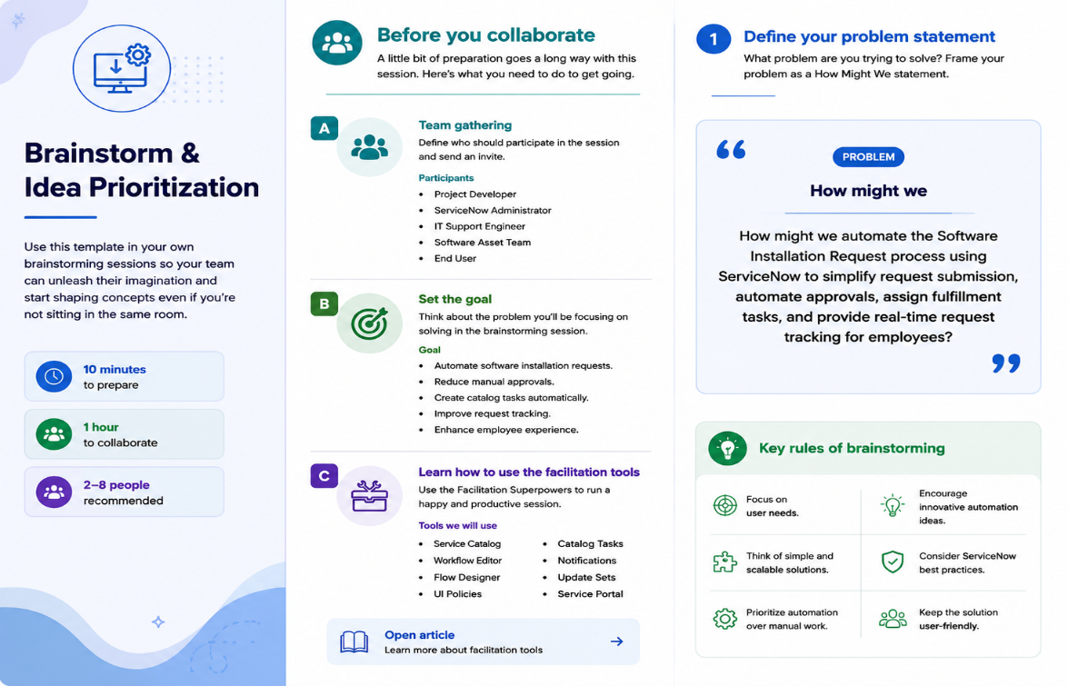
Step-2: Brainstorm, Idea Listing and Grouping
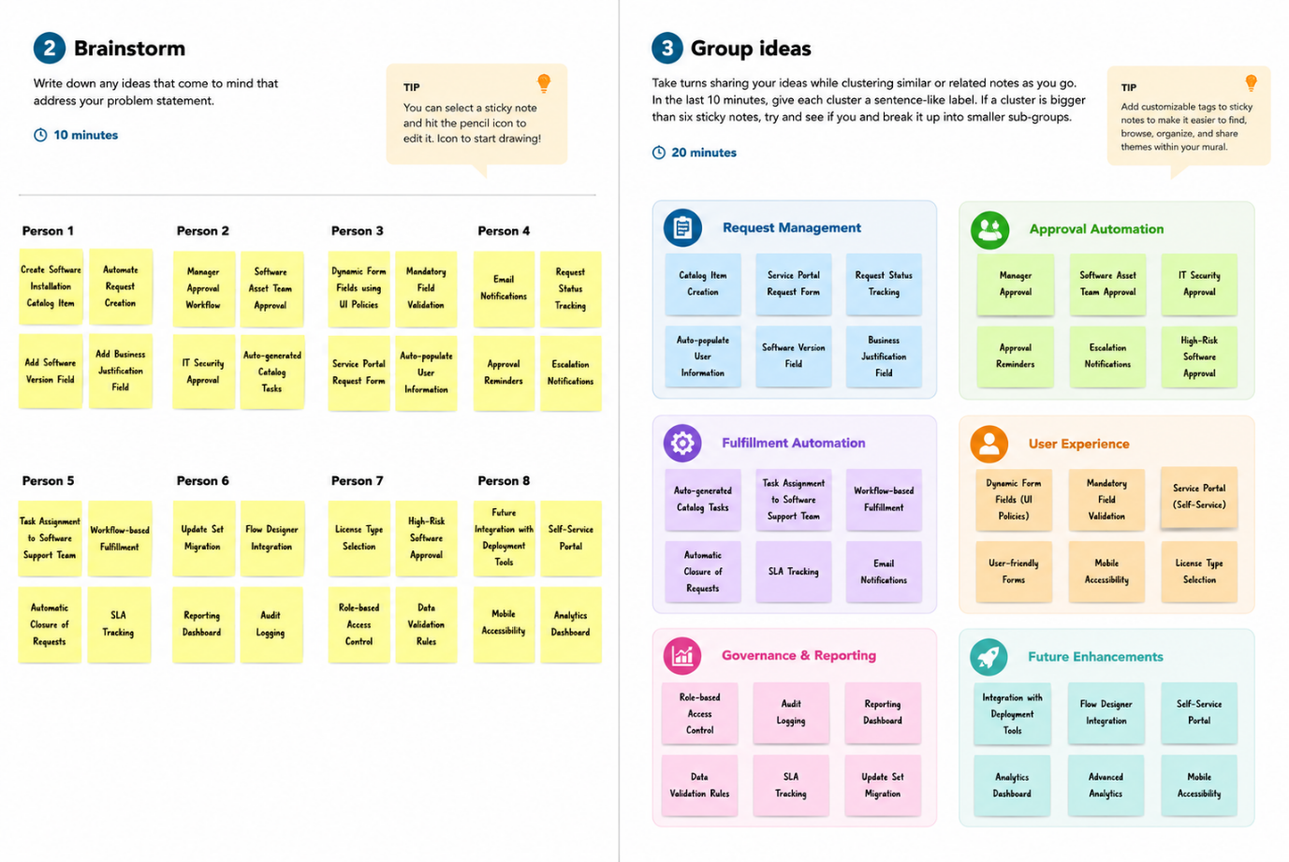
Step-3: Idea Prioritization
